***Assignment – 10***

**Joining a Table to Itself.**

1. Write a query that produces all pairs of salespeople who are living in the same city. Exclude combinations of salespeople with themselves as well as duplicate rows with the order reversed.

**select s1.sname , s2.sname from Salespeople s1 join Salespeople s2 on s1.city=s2.city where s1.snum<s2.snum;**



1. Write a query that produces the names and cities of all customers with the same rating as Hoffman.

**select c1.cname,c1.city from Customers c1 join Customers c2 on c1.rating=c2.rating where c2.cname='Hoffman';**

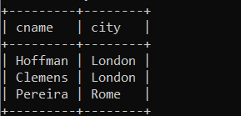

*Sameer Dehadrai* Page: 1